I like where you’re going — that’s exactly the C-suite language that resonates 👌.
You’ve taken the menu analogy and upgraded it to the kitchen metaphor — much stronger:
- Menu = discovery (what’s possible).
- Kitchen = infrastructure (how it’s made).
- Chefs = engineers/SMEs.
- Tools = data pipelines, APIs, governance.
- Layout = architecture (current poor design → needs rework).
- Orders = scale (how many requests we can serve reliably).

🔑 Roadmap / Obstacles Framed in the “Kitchen” Story
- Poor Kitchen Layout (Current State)
  - Tightly coupled with Vasara → hard to move around.
  - Inefficient workflows → engineers spend time “chopping vegetables” (manual fixes, firefighting).
- Upgrade Tools & Appliances (Immediate Fixes)
  - Invest in proper data pipelines (dishwasher/fridge/oven) → automation, validation, lineage.
  - Build a fit-for-purpose data model → standard recipes instead of improvising every time.
- Staffing & Roles (Operating Model)
  - Dedicated chefs for core dishes (data SMEs for modeling/curves).
  - Support staff for prep work (automation, pipelines) → free chefs to focus on cuisine (business innovation).
- Scalability & Capacity
  - Can the kitchen handle 500 orders/day (risk factor onboarding, large queries, historical rebuilds)?
  - Need orchestration + decoupling to scale horizontally.
- Future State — Michelin Kitchen
  - Decoupled from Vasara.
  - Clean data model.
  - Automated prep + pipelines.
  - Staff working at the right skill level, not stuck on menial tasks.
  - Ready to onboard new dishes (risk factors/products) fast.

🎤 Principles / Soundbites for the Roadmap
- “We can’t serve a 5-star menu with a broken kitchen.”
- “Our chefs should be designing dishes, not chopping onions.”
- “Scaling to 500 orders/day requires better layout, better tools, and a better prep line.”
- “Today’s kitchen is bolted onto Vasara’s walls — tomorrow’s must be modular and independent.”
- “Without proper knives, fridge, and dishwasher (pipelines & automation), we burn time instead of creating value.”
- “The goal is a Michelin-grade kitchen: scalable, efficient, and future-proof.”

Kitchen Analogy Applied to Vasara + MDSOR

🔻 Current Kitchen Problems (Obstacles)
- Chaotic Layout (Asynchronous Futures)
Execution jumps around — like cooks running in random directions waiting for missing ingredients. Debugging = near impossible.
- Opaque Chef (Evaluator)
The head chef (Evaluator) is shouting orders, but no one can see the recipes (Expressions). Hidden layers make onboarding new chefs (devs) painful.
- Random Ingredient Delivery (Futures)
Ingredients (time series) don’t arrive in sequence. You start cooking only when all crates show up — sometimes late, sometimes missing.
- Legacy Storage (Serialized Objects)
Ingredients are locked in jars labeled in a secret code (Java serialization). Only our chefs can open them, nobody else can use SQL or APIs.
- Strict Recipe Format (Mapping)
If the recipe card (risk factor key) has a typo, the dish comes out wrong or empty — and the system won’t warn you.
- Overworked Chefs (SMEs)
Instead of designing new dishes (models), they’re stuck chopping vegetables (debugging futures, fixing mappings).

✅ What the New Kitchen Needs (Roadmap)
- Decouple Pantry (MDSOR) from Stove (Vasara)
  - Today: tightly bound, serialized Java jars only usable inside Vasara.
  - Future: expose APIs / query layer → anyone can fetch ingredients cleanly.
- Redesign Kitchen Layout (Architecture)
  - Introduce clear data pipelines instead of tangled futures.
  - Make execution graphs observable (traceable flows).
- Better Tools & Appliances (Data Model + Pipelines)
  - Standard data model = common recipes, not tribal knowledge.
  - Pipelines = fridge/dishwasher → automate prep and cleanup.
- Staff in Right Roles (Operating Model)
  - Senior chefs focus on recipe innovation (risk models).
  - Prep staff (automation, tooling) handle chopping & cleaning (data prep, validations).
- Scalability & Reliability
  - Handle “500 orders/day” = risk factors at scale.
  - Monitoring, retries, circuit breakers to avoid stalls when futures don’t resolve.

🎤 Soundbites for C-Suite
- “Right now, our chefs are spending more time chopping onions than cooking dishes.”
- “We can’t build a 5-star menu on top of a kitchen with broken tools.”
- “Decoupling MDSOR from Vasara means one pantry that serves the whole restaurant, not just one stove.”
- “With proper layout and tools, we can onboard new dishes in days, not months.”

Soundbites for Architects
- “The current evaluator/future model gives performance, but at the cost of transparency.”
- “We need observability baked into the execution graph — otherwise debugging remains a black box.”
- “Replacing serialized objects with a queryable API turns brittle mappings into extensible schemas.”
- “Our design target is decoupled, composable, observable, and scalable.”

The Deephaven Query Language

Despite the fact that all of Deephaven's natively-supported types are Java types, the most common pattern for using Deephaven is through the Python API. So, how can these Java types be created or manipulated from Python? For this, Deephaven offers the Deephaven Query Language.
The Deephaven Query Language (DQL) is the primary way of expressing commands directly to the query engine. It is responsible for translating the user's intention into compiled code that the engine can execute. DQL is written with strings - called query strings - that can contain a mixture of Java and Python code

- A table is a structured data set consisting of columns and rows in a two-dimensional coordinate system.

Stream-processing systems are often unable to offer the full set of operations encountered in table-oriented systems (e.g., joins) without significant compromises. Table-oriented systems, like databases and dataframe packages, offer powerful tools for analyzing data, but these typically operate in a static or snapshot-driven manner.

As long as a source can be modeled as a structured table, it can be brought into Deephaven and commingled with other tables. We have invested significant effort to support in-situ access to partitioned, columnar data sources (e.g., Apache Parquet), as well as in-memory ingestion capabilities for other data sources like CSV files, pandas DataFrames, and more. As a result, Deephaven offers an empowering development solution for a wide range of data-driven applications, along with powerful interactive and offline data analysis for real-time data, static data, and combinations thereof.

If you're familiar with tabular data (think Excel, Pandas, and more), Deephaven will feel natural to you. In addition to representing data as tables, you must be able to manipulate, transform, extract, and analyze the data to produce valuable insight. Deephaven represents transformations to the data stored in a table as operations on that table. These table operations can be chained together to generate a new perspective on the data:

For the sake of efficiency and scalability, the engine is implemented mostly in Java. Although you primarily interface with tables and write queries from Python, all of the underlying data in a table is stored in Java data structures, and all low-level operations are implemented in Java. Most Deephaven users will interact with Java at least a little bit, and there are important things to consider when passing data between Python and Java.

Add API layer for dump, validate, analyze

Integrate analytics tools (Python, Dash, Streamlit, etc.)

4. Smart Loader Framework
Create loader processes that:
- Accept input as CSV, API, or Deephaven/KDB
- Convert to TimeSeriesSegment objects (e.g., one object per month)
- Auto-register metadata in TSMI
- Save Java-serialized blobs to data fabric (e.g., Ignite, Mongo, HBase)
🔁 The loader decides chunking strategy: per day, per month, or full snapshot.

- Java is strongly typed. All input parameters to methods must be of a specific data type.

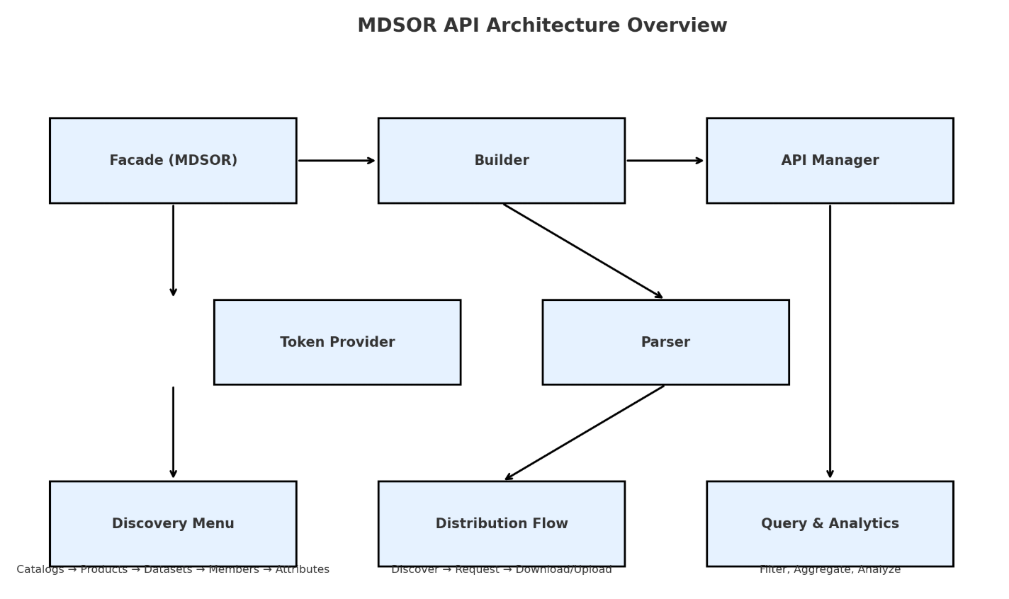

// ---------- Catalogs ----------

// ---------- Products ----------

// ---------- Data Dictionary ----------

// ---------- Datasets ----------

// ---------- Dataset resources / lineage

// ---------- Dataset members ----------

// ---------- Attributes ----------

// ---------- Distributions (download/upload) --

// ---------- Builders ----------

https://github.com/jpmorganchase/fusion-java-sdk/blob/main/src/main/java/io/github/jpmorganchase/fusion/Fusion.java

https://github.com/deephaven/deephaven-core/tree/main/DataStructures

